Huddle: COVID-19 Banking Edition C/A Top 10 FAQs April 15, 2020

- Can funds from stimulus deposits be used to cover overdrafts, related fees, garnishment and/or setoff?
There is unfortunately not enough guidance to determine whether permissible or not. Banks need to consider risks, including reputational, and regarding garnishment, Attorney Generals and Senators are petitioning the Treasury for stimulus checks to be free from garnishment except for child support, like social security checks. Ut at this time stimulus checks are not considered protected funds. The CARES Act already prohibits the IRS from garnishing for back-owed student loan payments.
Resource: https://ag.ny.gov/sites/default/files/04.13.20_multistate_letter_to_treasury_re_garnishment_and_cares_act_final.pdf
- What happens if a deposit is made in a joint stimulus amount to a joint account, but one of the persons is now deceased? Does the bank have any obligation?
C/A is of the opinion that joint deposits (ACH and check) are to be deposited into the account. For single payees, there is no specific guidance to this particular stimulus, but it was somewhat addressed by the IRS in 2008. However, we would recommend in the event of a single payee that is deceased, those be returned to prevent the representative from having to return it later.
See generally 2008 FAQ Guidance:
Q: If an individual dies, what happens to his or her direct deposit or stimulus check?
A. Stimulus payments will be issued in the name of the individual eligible for payment on a filed 2007 income tax return or to the account designated by the individual on that return. This includes situations where a person dies after filing a return or where the final 2007 income tax return was filed by a personal representative or surviving spouse. Any issues or concerns involving a decedent's filed return or the related stimulus payment should be addressed by the legal representative of the decedent's estate. See Publication 559 for more useful information for survivors and personal representatives. [Updated 3/17/08].
Resource: https://www.irs.gov/newsroom/economic-stimulus-payment-qas-eligibility
- Are banks permitted to “re-open” a closed account for stimulus ACH deposits?
The short answer is to check your account agreement and whether you have the general authority to re-open an account or if there was specific authority granted to reopen for specific circumstances. That will dictate what the bank is permitted to do here. There hasn’t been direct guidance on this question at this point, unfortunately. Conservatively, without contractual right, Compliance Alliance always advises not to “re-open” a closed account to accept any deposit, similarly to the best practice recommendation for IRS tax returns. Re-opening a closed account without the consent of the account owner could raise UDAAP and possibly legal issues, along with other risks like reputation. This is especially true if the account is charged off or otherwise subject to a right of set-off of course.
- Since the SBA released an additional FAQ #25, there is confusion still regarding beneficial ownership for those legal entities with 20% ownership and comparing that to FFIEC’s guidance of 25%. Can you shed some light on that?
Compliance Alliance interprets this new FAQ to say that the SBA requirements (which are separate from beneficial ownership requirements) require listing "all owners of 20% or more of the equity of the Applicant"
See generally: https://home.treasury.gov/system/files/136/PPP-Borrower-Application-Form-Fillable.pdf
In other words, that information would still be required specifically on PPP applications as set out in the link. The FAQ is stating that because banks already have to collect information for the 20% requirement on PPP loans, the Agencies are going to let you use this same information for beneficial ownership as well. However, this is only in relation to PPP loans; this is not giving the bank the same requirement for all beneficial ownership scenarios outside of PPP.
Resource: https://home.treasury.gov/system/files/136/Paycheck-Protection-Program-Frequently-Asked-Questions.pdf
25. Question: Does the information lenders are required to collect from PPP applicants regarding every owner who has a 20% or greater ownership stake in the applicant business (i.e., owner name, title, ownership %, TIN, and address) satisfy a lender’s obligation to collect beneficial ownership information (which has a 25% ownership threshold) under the Bank Secrecy Act?
Answer:
For lenders with existing customers: With respect to collecting beneficial ownership information for owners holding a 20% or greater ownership interest, if the PPP loan is As of April 13, 2020 being made to an existing customer and the lender previously verified the necessary information, the lender does not need to re-verify the information. Furthermore, if federally insured depository institutions and federally insured credit unions eligible to participate in the PPP program have not yet collected such beneficial ownership information on existing customers, such institutions do not need to collect and verify beneficial ownership information for those customers applying for new PPP loans, unless otherwise indicated by the lender’s risk-based approach to Bank Secrecy Act (BSA) compliance.
For lenders with new customers: For new customers, the lender’s collection of the following information from all natural persons with a 20% or greater ownership stake in the applicant business will be deemed to satisfy applicable BSA requirements and FinCEN regulations governing the collection of beneficial ownership information: owner name, title, ownership %, TIN, address, and date of birth. If any ownership interest of 20% or greater in the applicant business belongs to a business or other legal entity, lenders will need to collect appropriate beneficial ownership information for that entity. If you have questions about requirements related to beneficial ownership, go to https://www.fincen.gov/resources/statutes-and-regulations/cdd-final-rule. Decisions regarding further verification of beneficial ownership information collected from new customers should be made pursuant to the lender’s risk-based approach to BSA compliance.
- Is there clarification on the 10-day funding requirement whether that is business or calendar days for PPP loans?
The latest official guidance on this point in the FAQ below indicates that it's based on ten calendar days:
20. Question: The amount of forgiveness of a PPP loan depends on the borrower’s payroll costs over an eight-week period; when does that eight-week period begin?
Answer: The eight-week period begins on the date the lender makes the first disbursement of the PPP loan to the borrower. The lender must make the first disbursement of the loan no later than ten calendar days from the date of loan approval.
Resource: https://home.treasury.gov/system/files/136/Paycheck-Protection-Program-Frequently-Asked-Questions.pdf
However, this is a missing piece of information in the FAQ. Conservatively, timing should begin when the bank receives the email from the SBA indicating the SBA has received the application and assigned it an SBA loan number.
- Does Compliance Alliance have a checklist of documents that are necessary to close a PPP loan? We know the Borrower application and Lender application are required but we aren’t sure what else. Does CA have a checklist it could provide?
Compliance Alliance has published its Paycheck Protection Program Underwriting Checklist, and the rest of its PPP and general COVID tools here: https://compliancealliance.com/about-us/pandemic-planning-for-banks.
- How should banks be accounting for loan modification not under Section 4013?
A new Interagency Statement on Loan Modification and Reporting for Financial Institutions Working with Customers Affected by the Coronavirus (Revised) was recently issued April 7, 2020. If a loan modification is eligible, a bank may elect to account for the loan under section 4013 of the CARES Act. Section 4013 of the CARES Act, “Temporary Relief from Troubled Debt Restructurings,” provides banks the option to temporarily suspend certain requirements under U.S. GAAP related to troubled debt restructurings (TDR) for a limited period of time to account for the effects of COVID-19. If a loan modification is not eligible under section 4013, or if the bank elects not to account for the loan modification under section 4013, the Revised Statement includes criteria when a bank may presume a loan modification is not a TDR in accordance with ASC 310-40. If the criteria are not met under either section 4013 of the CARES Act or the Revised Statement, the bank should follow its existing accounting policies to determine whether the modification should be accounted for as a TDR. The chart below provides a summary of the respective criteria.
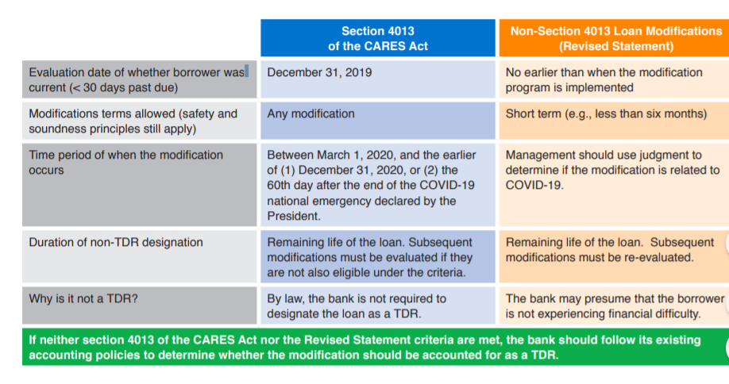Resource: https://www.occ.treas.gov/news-issuances/bulletins/2020/covid-19-loan-modifications-reference-guide.pdf
- PPP: The bank has a company that has several partners and no one owns 20% or more of the business. What does the bank do about listing a principal on the application? Or, what does the bank do when the applicant is a church or non-profit with no principal owner?
The purpose of this section within the application is to assist in determining whether the PPP affiliation rules apply—those rules hinge on a 20% ownership threshold test. If there are no 20% or more owners, the PPP affiliation rules would not be implicated and it is accurate to leave that section blank. While it is not specifically talking about beneficial ownership, it’s a similar concept and process, if an analogy was to be used.
- PPP: I have a customer that is an LLC. The only employees are the partners. They don’t issue W-2’s, but I have their K-1’s. Is this what I would use to justify the loan amount requested?
Like everything with the PPP there are unanswered questions—this is not specifically addressed but generally payroll costs would be the earnings the LLC is taxed on. Potentially, this would be the full amount of the net profit, not owner draws. With multiple partners, it’s interpreted to be the share of the business profits in 2019 according to ownership percentage (generally found on each member’s Schedule K-1 looking specifically at self-employment income).
- Can the bank have any payment structure they choose? Ex: 6mos deferred with 18 equal payments or one balloon payment due at the 24th month.
Conservatively, no—SBA 7(a) loans cannot have balloon payments and must have monthly payments of principal and interest (See: https://www.sba.gov/sites/default/files/oed_files/7a_Fact_Sheet.pdf generally). Additionally, the Final Rule implies the deferral period for payments should not be longer than 6 months:
When will I have to begin paying principal and interest on my PPP loan?
You will not have to make any payments for six months following the date of disbursement of the loan. However, interest will continue to accrue on PPP loans during this six-month deferment. The Act authorizes the Administrator to defer loan payments for up to one year. The Administrator determined, in consultation with the Secretary, that a six-month deferment period is appropriate in light of the modest interest rate (one percent) on PPP loans and the loan forgiveness provisions contained in the Act.
Resource: https://www.sba.gov/sites/default/files/2020-04/PPP--IFRN%20FINAL_0.pdf

